

**OFFICE OF THE PRESIDENT**

**DATE :** June 8, 2020

**TO :** All Concerned

**SUBJECT : Guidelines on Re-entry of Employees and READS and** **Entry of Visitors in the School Campus under GCQ**

For your reference, we are forwarding to you the attached “GUIDELINES ON RE-ENTRY OF EMPLOYEES AND READS IN THE SCHOOL CAMPUS UNDER GENERAL COMMUNITY QUARANTINE” and “GUIDELINES ON THE ENTRY OF VISITORS IN THE SCHOOL CAMPUS” for the information and dissemination to all concerned.

Thank you for your attention and cooperation.

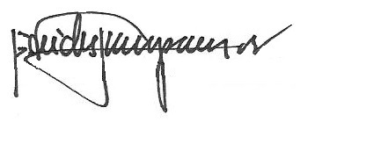

REV. FR. CRISTOPHER C. MASPARA, OAR

University President